Mining Periodic Subgraphs in Drosophila Developmental Networks

Mohammad Shafiqul Islam
Department of Electrical and Computer Engineering
North South University
Dhaka, Bangladesh
mdshafiqul.islam@northsouth.edu
Mohammad Rafsun Jany Mahin
Department of Electrical and Computer Engineering
North South University
Dhaka, Bangladesh
jany.mahin@northsouth.edu
Ahsanur Rahman
Department of Electrical and Computer Engineering
North South University
Dhaka, Bangladesh
ahsanur.rahman@northsouth.edu

Abstract—For the past few years, periodic subgraph mining in dynamic networks has gained a lot of attention in different fields of research. However, not much work has been done in this regard in the field of network biology. This work attempts to fill this gap by finding subnetworks that appear periodically several times during Drosophila development. We first computed periodic subgraphs from a sequence of time varying gene networks using an existing tool. We suggested how to choose an appropriate parameter setting for this tool. We also did enrichment analysis of the largest connected component of the periodic subnetworks as well as the hub genes and dense subgraphs in it. Our results show that the proposed method can successfully identify periodically active gene-functions and transcription factors during the development of Drosophila. We have also compared our results with a baseline method which computes recurrent dense subgraphs in an ensemble of networks and found that the baseline method generates many spurious clusters irrelevant to the periodically active gene functions whereas our approach can successfully mine those functions.
Keywords—periodic subgraph, graph mining, Drosophila developmental networks, dynamic networks, functional enrichments

Introduction
In recent years, graph mining has attracted the attention of a lot of researchers. One of the main goals of graph mining is to find interesting patterns from one or more graphs. Such patterns include hubs [1], dense subgraphs [2], frequent dense subgraphs [3], periodic subgraphs [4], and so on. Different patterns are useful for different purposes. For example, hubs tend to indicate leaders in a social network and essential genes in a protein-protein interaction (PPI) network [5], dense subgraphs often reveal underlying communities in a social network [6], frequent dense subgraphs tend to indicate communities in a sequence of communication networks [7], periodic subgraphs tend to indicate periodically formed communities in dynamic social networks [4], and so on.
Among them, periodic subgraph mining is one of the least studied problems. Especially, we couldn’t find any study that identifies periodic subgraphs in time-varying protein/gene interaction networks. Therefore, it is an important to fill up this gap in the extant body of knowledge. Moreover, these periodic subgraphs have high potential to give us interesting insights of the underlying biology of the cell. Our intuition comes from the following literature review.
It is well-known that multiple processes get activated periodically to regulate/maintain cell-cycle [9] and circadian rhythm (sleep-wake cycle) [10]. Periodic oscillation was also observed in the abundance of diverse cellular molecules such as cAMP secreted by starved Dictyostelium discoideum (period is about 5 min), cytosolic Ca⁺⁺ ion (period depends on cell type), transcription factor NF-KB (period is about 100 min), tumor suppressor p53 (period is a few hours), etc [10].
Biological experiments have also shown that some cellular functions and regulators are activated periodically during organism development. For example, cell cycle occurs every 30 min during amphibian embryonic development and is driven by the periodic activation of MPF [10]. In vertebrate embryos, Notch signaling pathway periodically activates cellular processes responsible for somitogenesis [10]. Motoneurons exhibit periodic bursts of activities during the early development of spinal cord in chick and mouse [8]. Also, during the development of mouse and some other vertebrates, a transient neural network cause the generation of periodic waves of activities in the retina (known as retinal waves) [9].
These literature reviews suggest that some subnetworks of genes in the development networks may arise periodically – (i) in order to regulate periodic cues and/or (ii) as a response to such cues. In fact, recent advances in experimental biology suggests that the intensities of molecular interactions within a cell vary spatiotemporally; thereby resulting in a dynamic interaction network [13]. Finding periodic subgraphs within such a dynamic network may shade light on both the periodic cellular processes and their regulators.
These observations motivated us to compute periodic subgraphs within time-varying gene networks. We made the following contributions in this work.
- We demonstrated the importance of mining periodic subgraphs in time-varying gene networks on the basis of extensive literature review.
- We suggested how to choose appropriate parameter combinations to compute periodic subgraphs and used those parameters to compute periodic subgraphs from a dataset of temporal gene networks.
- We computed the largest connected component of each periodic subgraph as well as the hub genes and dense subgraphs within that component. Then we have done a number of analyses on those to show that they are involved in known periodic processes and are regulated by periodic genetic regulators.
- We compared our results with a baseline method which computes recurrent dense subgraphs in an ensemble of networks and found that the baseline method generates many spurious clusters irrelevant to the periodically active gene functions whereas our approach can successfully mine those functions.
Rest of the paper is organized as follows. Section II illustrates the notion of periodic subgraphs. Section III discusses relevant works. Section IV sheds light on the network dataset we chose to compute periodic subgraphs and justifications to choose it. Section V demonstrates our complete pipeline of finding periodic subgraphs and analyzing them for their biological significance. We discuss our results in Section VI. We conclude in Section VII and provide future directions in Section VII.

Periodic Subgraph Illustration
We demonstrate the concept of periodic subgraphs in the temporal networks shown in Fig. 1. This figure shows first six snapshots of a time-varying network over seven genes. Here each node is a gene involved in Drosophila’s development and an edge exist between two genes if they are likely to be co-regulated (see Section IV for details). These genes were chosen because they are biologically interesting. Specifically, Nrt, dock, brm, Src64b, and msn are involved in neuron projection guidance and the master regulator gene Notch (N) regulates this process [11]. Thus this network dataset serves as a motivating example for periodic subgraphs.
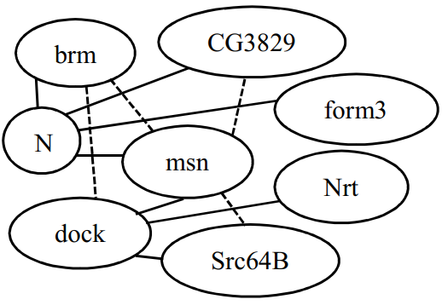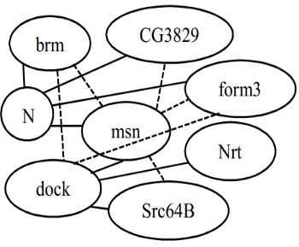
T = 1
T = 2

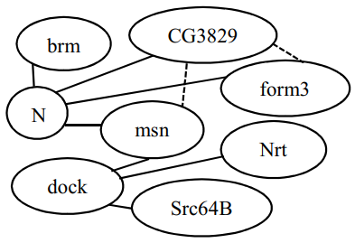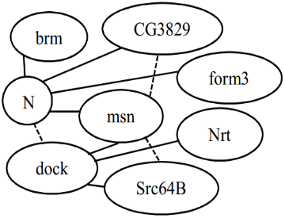
T = 4
T = 3

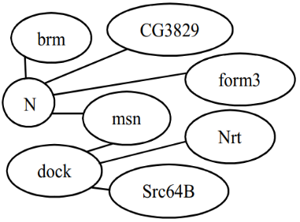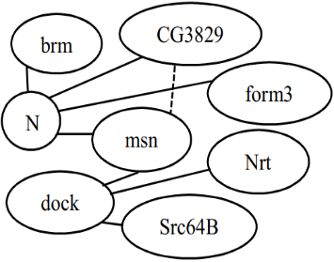
T = 6
T = 5

- Example of first six timesteps of Drosophila developmental network. Here, the edge (CG3829, msn) is a periodic subgraph having period 2, support 3, and support set {2, 4, 6} starting from T = 2. The straight lines represents the edges that are not changing throughout the timesteps, where the dotted lines are changing.
Most interactions in Fig. 1 occur in every timestep (shown as solid lines). Only a few interactions exhibit variations from these networks, if we consider the subgraph H = {(CG3829, msn)}. The set of timesteps in which H occurs is {1, 2, 3, 4, 6}. This set is known as the support set of H. Since H occurs at every timestep from 1 to 4, we call it a periodic subgraph with period 1 and support 4, or a (1, 4)-periodic subgraph, in short. To be precise, we call it a (1, 4)-periodic subgraph with support set {1, 2, 3, 4}. H can also be called a (2, 3)-periodic subgraph with support set {2, 4, 6} because H occurs at 3 timesteps where consecutive timesteps are separated by 2 steps, i.e., it has period 2 and support 3.
With this illustration, we are now ready to formalize this informal definition of periodic subgraphs.
Definition 1. Periodic Subgraph: Given a dynamic network G, a subgraph F is called a (p, s)-periodic subgraph with support set S in G if it satisfies the following conditions.
- Periodicity: Two consecutive timesteps in S are separated by p timesteps.
- Minimum Support: Size of S, |S| ≥ $σ$ where $σ$ is the minimum value of support, given by the user.
- Structural Maximality: No other nodes or edges can be added into subgraph F because if we do so then the modified F does not have period p or support s anymore.
- Temporal Maximality: No other timestep can be added to the support set S because if we do so then F does not have period p or support s anymore.
These definitions are adapted from Lahiri and Berger-Wolf [4].

Related Works
To the best of our knowledge, no research before this one was conducted to identify periodic subgraphs in time-varying gene networks in order to elucidate their biological significance. Therefore, we discuss other works that are closely related to us. We can classify these works into the following two categories.
Mining Periodically Co-expressed genes: Some research applied mathematical/statistical techniques (for example, Fourier analysis) upon temporal gene expression profiles in order to discern clusters of genes that are periodically co-expressed [16], [17]. These works are not applicable to temporal gene networks – which are becoming more and more available with the recent development of novel experimental techniques.
Mining Periodic Subgraphs: Lahiri and Berger-Wolf [4] developed a mining algorithm called PSEMiner which maintains a list of periodic subgraphs for each timestep that has been read so far. This process continues till the last timestep T. Their algorithm had a time complexity of O((V+E)T³lnT) for vertex V, edge E when the parameter P_{max} (maximum periodicity) is not given and O((V+E+P_{max}²) T²lnT) when P_{max} is given. Their purpose was to find the least set of periodically recurring subgraphs that earn the periodic behavior in a dynamic network.
Apostolico, Barbares and Pizzi [10] were interested in finding the graphs that recur at regular interval. From all periodic graphs, their particular concern was in those that cannot be enriched by adding new edges without losing support.
Later, they built an algorithm named ListMiner with time complexity O((E+V)(T² ln(T/σ)). The uniqueness of this algorithm is it does not need to know population in advance. So, it added the new incoming vertex online. They found that their algorithm outperformed PSEMiner on most datasets. As ListMiner had a better performance we used ListMiner to find the periodic subgraphs in our work.

Dataset
To be able to identify periodic subgraphs, we needed a time-varying network dataset. We collected a dataset [13] consisting of 66 temporal undirected networks for this purpose. These networks were inferred from the temporal expression profile of 588 genes involved in the development related processes in Drosophila. Each network represents the binary associations among these 588 genes at a certain timestep during Drosophila’s development and an edge between two genes in it indicates that these genes are probably co-regulated at that timestep.
The procedure to infer these networks is briefly described here in order to make the reader understand our rational and motive for choosing this dataset. Firstly, a microarray dataset was collected. This dataset contained temporal expression of 4028 genes sampled at 66 distinct time-periods over the first 40 days Drosophila’s life, spanning four stages of its development: embryonic stage, larval stage, pupal stage, and adult stage [14]. Then a type of logistic regression method (called kernel reweighed l1-regularized logistic regression, or KELLER, in short) was applied on only the expression profiles of development-related genes (588 of total 4028 genes) in such a way that – (i) there should be an edge between two genes at timestep t if their expressions vary in a correlated manner near t and (ii) temporally adjacent networks share many more interactions than the distant ones (this is achieved by assigning more weights to the observations near timestep t and gradually decreasing the weights assigned to distant observations). This second constraint tries to ensure that the topology of the inferred networks vary slowly/smoothly over time. Therefore periodic subgraphs are less likely to arise in such networks due to mere spurious correlations. Another reason to choose this dataset is that it allows us to elucidate periodic processes across distinct timesteps within a developmental stage as well as over diverse stages.
of the network. The contributing genes of an edge in a network are given as some numeric values. For example, an edge between the genes: spn-A and Borr is represented by 64 and 83 respectively.

Mining Methodology
Our proposed methodology for mining periodic subgraphs in Drosophila developmental networks consists of several stages. At first, we have done some preprocessing of the data. Then we choose a suitable period and support cut-offs to apply ListMiner algorithm to find the periodic subgraphs. After that, we have counted the number of genes for each parameter combination to find the suitable ones. Then we continued to the next step, finding the largest connected components for our selected parameters. Finally, we also have computed the functional enrichment of genes covered by these components to find the specific genes which are biologically enriched. We have used MATLAB and Python programing with other standalone applications such as Cytoscape, Funcassociate, Ontologizer, NetsTensor in different stages to generate the desired outputs.
Fig. 2 is a visual flowchart of the whole methodology.

- Overview of Mining Methodolgy.

Data Preprocessing
As the format of the KELLER data and the input format of ListMiner algorithm do not match, some preprocessing was done.
We start with extracting the all edges of the networks individually. Then, all the edges of the 66 networks are copied to a single file and the duplicate edges are removed. As per the algorithm’s input requirement, we have to give a number starting from 589 to all the individual edges because 1 to 588 are the gene numbers. Finally, we sort all the edges according to the individual timesteps.
Fig. 3, Fig. 4, Fig. 5, and Fig. 6 respectively show a reflection of how the original KELLER data is transformed into ListMiner input format.
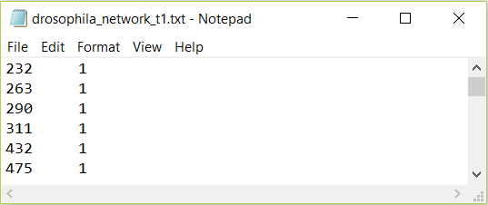

- Original KELLER data only for timestep 1 (partial) after extraction.
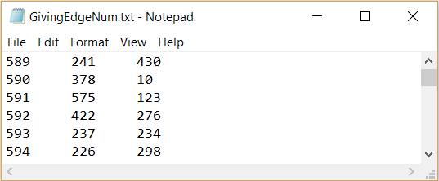

- Giving the edges number (partial).

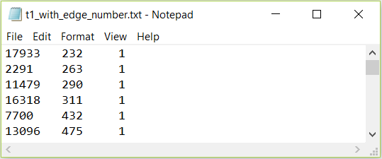
- Sorting the edges numbers for the timestep 1 (partial).

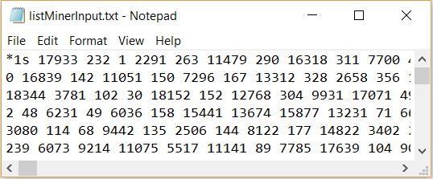
- Partial input for ListMiner (*1s means timestep 1).

Algorithm Apply
When the input format is ready, we applied the ListMiner algorithm to find the periodic subgraphs. We have slightly modified the algorithm as the requirement for different period and support cutoffs. For example, as there are total 66 developmental networks, we call the algorithm for period 2 to (66/3) and for every period, the support range is 3 to (66/period). From the output of the algorithm, we have multiple subgraphs for each parameter combination. Then, we have filtered out the edges and remapped the numeric values to Gene names accordingly. Fig. 7 is showing a partial output of the algorithm and Fig. 8 is the partial gene names representation.
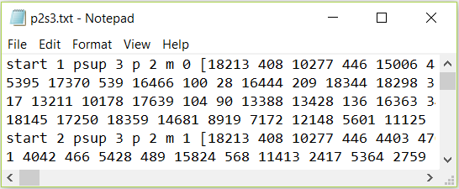

- Partial Output for period 2, support 3 after applying ListMiner. Here, start is the staring point (network/timestep) of the subgraph, psup means support, p means period, m means phase ( which is not needed for this research) and the square braces contain the subgraph. The first subgraph represents, it will be found in timesteps 1, 3, and 5 as the starting timestep is 1, the support is 3 and the period is 2.
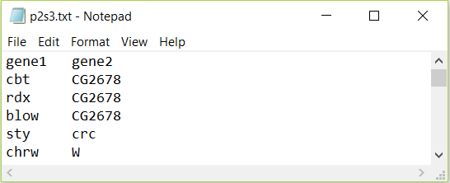

- Partial gene name representation of the subgraph for period 2, support 3.

Parameter Choosing
Although we have computed the periodic subgraphs for all possible parameter combination, all of them may not be significant for our further work as some of the parameters has very small number of subgraphs.
For choosing the right parameter, at first we create two 2d matrices. One of them shows the number of subgraphs for each combination of parameters. The other one shows the total number of unique genes covered by the subgraphs that we have found for each combination of parameters. Table. 1 displays first matrix which the number of periodic subgraphs. Here, empty cells represent that no periodic subgraph has been found for that parameter. We can see that the number of graphs are decreasing when the periods and supports both are increasing.
- Number of Periodic Subgraphs for Each Parameter Combination (partial)
Periods | Supports
 | 3 | 4 | 5 | 6 | 7 | 8 | 9
2 | 692 | 415 | 267 | 160 | 104 | 57 | 33
3 | 491 | 244 | 127 | 60 | 34 | 17 | 8
4 | 388 | 156 | 64 | 27 | 11 | 4 | 3
5 | 300 | 101 | 35 | 10 | 5
6 | 243 | 70 | 18 | 5
7 | 189 | 42 | 10
8 | 149 | 25 | 3
9 | 144 | 15

Table. 2 is the visual representation of the second matrix. It shows the number of unique genes for each parameter combination. Here, we again see that the number of unique genes are decreasing as long as the periods and supports are increasing. Another interesting finding is that the genes of a parameter are the subset of its ancestors (both period and support).
Based on these observations we decided to choose parameters in such a way that (i) both of period and support are not too low and (ii) number of genes is not too low. Our reasoning for choosing parameters in such a way are as follows. Firstly, there exist numerous periodic subgraphs with very low period and support (see top-left corner of table I) which indicates that most of them exhibit periodicity probably because of noise rather than due to actual biological cues. Secondly, one of our goals was to understand why a set of genes show periodic inter-connections: are they involved in any periodic process in the cell (such as cell cycle)? Are they regulated by a periodically active transcription factor (TF)? Definite answers to such questions can’t be obtained if the number of genes in the concerned set is too low. Because small set of genes tend to share many biological functions (a phenomenon known as multi-functionality [21]) and as such it is difficult to identify the process because of which these genes exhibit periodicity. That’s why we stipulated that the number of genes cannot be too low (specifically, cannot be less than a hundred) in a periodic subgraph.
Applying these heuristic rules, we selected two parameter combinations: (period 2, support 8) and (period 7, support 3). These parameter choices are highlighted in Table II (the colored two cells). The motive for choosing these two is we want to consider the both cases which are, one parameter will have a small period but large support and the other one will be the vice versa.
- Number of Unique Genes Covered by the Subgraphs for Each Parameter (Partial)
Periods | Supports
 | 3 | 4 | 5 | 6 | 7 | 8 | 9
2 | 588 | 570 | 471 | 349 | 234 | 155 | 58
3 | 576 | 433 | 231 | 135 | 44 | 12 | 7
4 | 502 | 242 | 60 | 13 | 7 | 2 | 2
5 | 379 | 141 | 13 | 2 | 2
6 | 262 | 52 | 7 | 2
7 | 169 | 17 | 2
8 | 77 | 7 | 2
9 | 55 | 2

Compute Largest Connected Component and Dense Subgraphs
The periodic subgraph for each of our chosen parameter combinations contained multiple connected components. Among them we chose the largest component
P2s8: 286 milli-seconds, p7s3: 292 ms.
We got 57 (respectively, 189) periodic subgraphs having period 2 and support 8 (respectively, for period 7 and support 3). Many of them have multiple connected components. Among all the components across these periodic subgraphs, the largest component was chosen for biological significance analysis (discussed in the next section). The reason for choosing the largest component is that connected set of genes/protein tend to be more biologically meaningful than disconnected ones and large set of genes tend to be more meaningful than the smaller ones. We then applied ClusterOne algorithm [22] on this component to identify dense subgraphs in it. The largest component (cyan colored) and the dense subgraphs (yellow and purple colored) in it are shown in Figures 9-10 and their properties are described in Tables. We used Cytoscape network visualization and analysis platform [23] to find largest components and the dense subgraphs.
We have found in a specific subgraph for period 2 and support 8 that has the staring timestep 1. So this subgraph as well as the largest connected component was found in timesteps 1, 3, 5, 7, 8, 9, 11, and 13. The largest connected component for this parameter has total 33 unique genes with 56 edges among 94 unique genes and 102 edges.
Then, for period 7 and support 3, we have the largest connected component with staring point 1 among total 189 subgraphs and the subgraph that has the largest connected component will be found in timesteps 1, 8, and 15. The largest connected component consists of 39 unique genes and 64 edges where the subgraph that contains the largest connected component has 103 unique genes and 112 edges.
Fig. 9 and Fig. 10 show these two largest connected component with their dense subgraphs below respectively.

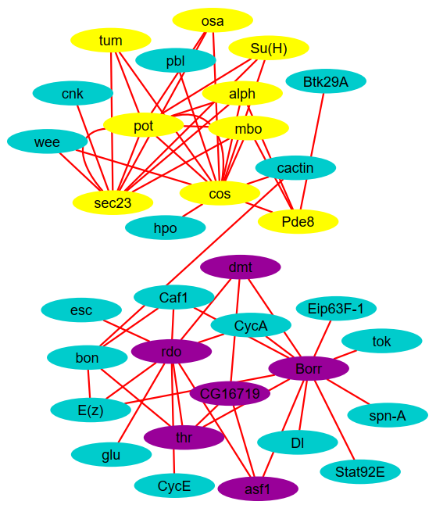
- Largest Connected Component for Period 2 and Support 8. The yellow and purple colored nodes represents the two dense subgraphs.
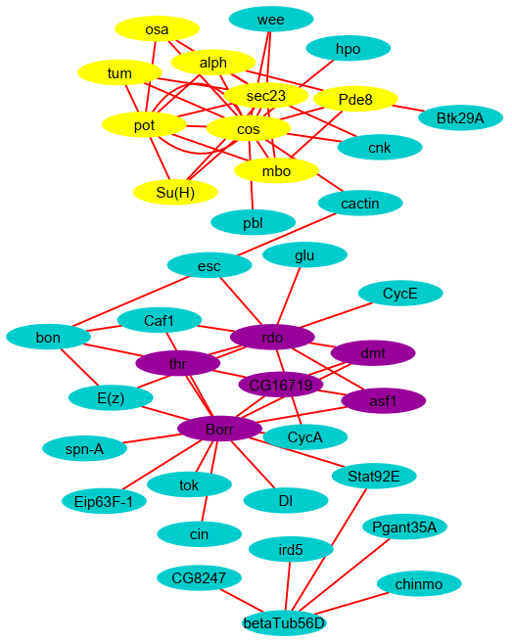

- Largest Connected Component for Period 7 and Support 3. The yellow and purple colored nodes represents the two dense subgraphs.

Biological Significance Analysis
We have converted the gene names to ensemble gene id namespace.
- MGSA Enrichment of the Largest Connected Component for Each Parameter
Parameters | Highly Enriched GO Term | MGSA Score (0~1)
Period 2, Support 8 | Chromosome Organization | 0.68
 | CAF1 Complex | 0.64
Period 7, Support 3 | Chromosome Organization | 0.54
 | CAF1 Complex | 0.60

Gene Ontology (GO)

Biological Process
- FuncAssociate enrichment of sorted (by degrees) list of nodes in the largest component
Highly Enriched GO Term | LOD ratio | Adjacent P-value
CAF1 Complex | 2.58 | 0.04
Nucleosome Assembly | 2.02 | 0.019
Protein-DNA Complex Assembly | 2.02 | 0.019
Chromatin Organization | 1.29 | 0.001
- FlyEnrichr with Revigo Enrichment of GO Biological Process (p2s8)
ID | Name | FR Adj. P- val. | FR Comb.  Score | RG  Dis. | Genes
GO:1902808 | positive regulation of cell cycle G1/S phase transition | 4.64E-05 | 40.52 | 0 | Su(H), CycA, CycE
GO:0007422 | peripheral nervous system development | 2.33E-10 | 39.72 | 0.03 | bon, glu, CycA, Dl, CycE, dmt, pbl, thr
GO:0031062 | positive regulation of histone methylation | 1.62E-03 | 34.05 | 0.28 | E(z), esc
GO:0007476 | pmaginal disc-derived wing morphogenesis | 7.01E-10 | 30.24 | 0.3 | Su(H), cnk, tok, Btk29A, cos, Dl, CycE, Stat92E, osa, alph
GO:0060541 | pespiratory system development | 2.33E-06 | 25.02 | 0.34 | Btk29A, Dl, dmt, Stat92E, mbo, thr
- FlyEnrichr with Revigo Enrichment of GO Biological Process (p7s3)
ID | Name | FR Adj. P- val. | FR Comb.  Score | RG  Dis. | Genes
GO:1902808 | positive regulation of cell cycle G1/S phase transition | 8.16E-05 | 38.99 | 0 | Su(H), CycA, CycE
GO:0007422 | peripheral nervous system development | 1.06E-09 | 37.65 | 0.03 | bon, glu, CycA, Dl, CycE, dmt, pbl, thr
GO:0031062 | positive regulation of histone methylation | 2.54E-03 | 32.80 | 0.28 | E(z), esc
GO:0060541 | respiratory system development | 2.20E-07 | 28.84 | 0.29 | Btk29A, Pgant35A, Dl, dmt, Stat92E, mbo, thr
GO:0007476 | imaginal disc-derived wing morphogenesis | 4.75E-09 | 28.10 | 0.34 | Su(H), cnk, tok, Btk29A, cos, Dl, CycE, Stat92E, osa, alph

Cellullar Component
- FlyEnrichr with Revigo Enrichment of GO Cellullar Component (p2s8)
ID | Name | FR Adj. P- val. | FR Comb.  Score | RG  Dis. | Genes
GO:0035098 | ESC/E(Z) complex | 1.58E-03 | 27.82 | 0 | E(z), esc
GO:0000785 | chromatin | 3.54E-05 | 15.48 | 0.19 | bon, glu, E(z), esc, dmt, mbo
GO:0005634 | nucleus | 3.54E-05 | 15.15 | 0.15 | Su(H), bon, dmt, tum, Eip63F-1, glu, E(z), CycA, esc, CycE, Stat92E, pbl, osa
GO:0045170 | spectrosome | 3.61E-02 | 12.36 | 0.28 | CycA
GO:0005881 | cytoplasmic microtubule | 5.36E-02 | 9.10 | 0.3 | tum
- FlyEnrichr with Revigo Enrichment of GO Cellullar Component (p7s3)
ID | Name | FR Adj. P- val. | FR Comb.  Score | RG  Dis. | Genes
GO:0035098 | ESC/E(Z) complex | 2.42E-03 | 26.76 | 0 | E(z), esc
GO:0005634 | nucleus | 6.81E-05 | 14.91 | 0.15 | Su(H), bon, dmt, tum, Eip63F-1, glu, E(z), CycA, esc, chinmo, CycE, Stat92E, pbl, osa
GO:0000785 | chromatin | 6.81E-05 | 14.15 | 0.19 | bon, glu, E(z), esc, dmt, mbo
GO:0045170 | spectrosome | 3.72E-02 | 11.72 | 0.28 | CycA
GO:0035060 | brahma complex | 5.01E-02 | 8.66 | 0.3 | osa

Molecular Function
- FlyEnrichr with Revigo Enrichment of GO Molecular Function of (p2s8)
ID | Name | FR Adj. P- val. | FR Comb.  Score | RG  Dis. | Genes
GO:0046974 | histone methyltransferase activity (H3-K9 specific) | 1.38E-03 | 38.94 | 0 | E(z), esc
GO:0016538 | cyclin-dependent protein serine/threonine kinase regulator activity | 4.76E-03 | 16.50 | 0 | CycA, CycE
GO:0004114 | 3',5'-cyclic-nucleotide phosphodiesterase activity | 5.46E-02 | 13.87 | 0.08 | Pde8
GO:0001085 | RNA polymerase II transcription factor binding | 6.63E-03 | 13.43 | 0 | Su(H), asf1
GO:0004715 | brahma complex | 5.46E-02 | 13.27 | 0.26 | Btk29A
- FlyEnrichr with Revigo Enrichment of GO Molecular Function of (p7s3)
ID | Name | FR Adj. P- val. | FR Comb.  Score | RG  Dis. | Genes
GO:0046974 | histone methyltransferase activity (H3-K9 specific) | 2.13E-03 | 37.64 | 0 | E(z), esc
GO:0005112 | Notch binding | 6.73E-03 | 19.89 | 0 | Pgant35A, Dl
GO:0004653 | polypeptide N-acetylgalactosaminyltransferase activity | 6.42E-02 | 18.80 | 0.26 | Pgant35A
GO:0016538 | cyclin-dependent protein serine/threonine kinase regulator activity | 7.13E-03 | 15.76 | 0 | CycA, CycE
GO:0004114 | 3',5'-cyclic-nucleotide phosphodiesterase activity | 6.47E-02 | 13.27 | 0.08 | Pde8

Trancription Factors
- Transcription Factor (TF) Enrichment Using FlyEnrichr (ER), Funcassociate (FA), and Revigo (RG) of the Dense Cluster with 9 Genes
ID | Name | FA Adj. P- val. | FA LOD Score | RG  Dis. | TF | ER Adj. P- val. | Genes
GO:0007501 | meso-derm-al cell fate speci-ficati-on | 0.011 | 2.928 | 0 | dl | 0.02 | Su(H), Pde8, pot, cos, mbo, osa, tum, alph
 |  |  |  |  | twi | 0.05 | Su(H), Pde8, cos, osa, tum, alph
GO:0007507 | heart deve-lopm-ent | 0.002 | 2.416 | 0.17 | dl | 0.02 | Su(H), Pde8, pot, cos, mbo, osa, tum, alph
 |  |  |  |  | Med | 0.02 | Su(H), Pde8, cos, mbo, osa, tum, alph
 |  |  |  |  | twi | 0.05 | Su(H), Pde8, cos, osa, tum, alph
GO:0006355 | regu-lation of trans-cription, DNA temp-lated | 0 | 2.343 | 0.03 | TfIIB | 0.02 | Su(H), cos, mbo, osa, tum, alph
 |  |  |  |  | BEAF-32 | 0.02 | Su(H), Pde8, pot, cos, mbo, osa, tum, alph
 |  |  |  |  | dl | 0.02 | Su(H), Pde8, pot, cos, mbo, osa, tum, alph
 |  |  |  |  | Med | 0.02 | Su(H), Pde8, cos, mbo, osa, tum, alph
 |  |  |  |  | Cp190 | 0.02 | Su(H), Pde8, pot, cos, mbo, osa, tum, alph
 |  |  |  |  | twi | 0.05 | Su(H), Pde8, cos, osa, tum, alph
 |  |  |  |  | h | 0.05 | Su(H), Pde8, cos, osa, alph
GO:0009950 | dorsal/vent-ral axis speci-ficati-on | 0.005 | 2.337 | 0.2 | dl | 0.02 | Su(H), Pde8, pot, cos, mbo, osa, tum, alph
 |  |  |  |  | Med | 0.02 | Su(H), Pde8, cos, mbo, osa, tum, alph
 |  |  |  |  | twi | 0.05 | Su(H), Pde8, cos, osa, tum, alph

Result and Comparison
Next, a web application named FuncAssociate by Berriz, Beaver and Cenik [12], used for functional trend analysis. This tool is used to find gene-set enrichment that is used to characterize gene-sets (also known as query genes). Here, query genes are those genes which the researcher finds interesting from all genes that has been experimented by the researcher. FuncAssociate has two modes one is ordered another is unordered. In unordered mode FuncAssociate calculate the p-value for each GO term and if the p-value is low then it can be said that GO term is highly enriched. In ordered mode FuncAssociate takes the query genes as ordered list and calculates the GO term. We have used FuncAssociate several times to find the gene enrichment in our experiment.
Another related approach that was done by Li et al. [3], named NetsTensor. Using NetsTensor algorithm, it can be shown that some particular idea is not similar to other types of inspect on a graph. NetsTensor algorithm is used to find dense subgraph that are frequent. It also can find clusters for a specific size and specific frequency.

Conclusion
Through our research, we have shown the importance of periodic subgraph in time varying gene network and also how to choose parameter combination in a dynamic network to find periodic subgraph. We have also demonstrated that how periodic subgraph is related to functional enrichment and how it effectively characterizes dynamic network. We also compute largest connected components, clusters for chosen parameter combination (p2s8, p3s7) and demonstrate how they are connected to periodic processes. Later part in our research we have compared our analysis with recurrent dense subgraph and found some significant result.

Future Directions
For the future of this work, a lot of research is still needed. There are some fascinating routes for the future research and we would like to highlight some of those. One particular direction is to implement this research on human genes. It would be very interesting to see how those human genes interact in a dynamic network. Not only human genes but genes which have similar pattern like drosophila can be also implemented. Another direction is to implement our own algorithm and develop a full pipeline for that algorithm through which other researcher can easily find functionalities for some particular network. Visualization of patterns which is not explored yet can be a challenging part also.

Acknowledgment
The preferred spelling of the word “acknowledgment” in America is without an “e” after the “g”. Avoid the stilted expression “one of us (R. B. G.) thanks ...”. Instead, try “R. B. G. thanks...”. Put sponsor acknowledgments in the unnumbered footnote on the first page.

References
- Y. R. Cho and A. Zhang, “Identification of functional hubs and modules by converting interactome networks into hierarchical ordering of proteins,” BMC Bioinformatics, vol. 11, no. SUPPL. 3, 2010.
- H. Hu, X. Yan, Y. Huang, J. Han, and X. J. Zhou, “Mining coherent dense subgraphs across massive biological networks for functional discovery,” Bioinformatics, vol. 21, no. SUPPL. 1, pp. 213–221, 2005.
- W. Li, C. C. Liu, T. Zhang, H. Li, M. S. Waterman, and X. J. Zhou, “Integrative analysis of many weighted Co-Expression networks using tensor computation,” PLoS Comput. Biol., vol. 7, no. 6, 2011.
- M. Lahiri and T. Y. Berger-Wolf, “Periodic subgraph mining in dynamic networks,” Knowl. Inf. Syst., vol. 24, no. 3, pp. 467–497, Sep. 2010.
- N. Pržulj, D. A. Wigle, and I. Jurisica, “Functional topology in a network of protein interactions,” Bioinformatics, vol. 20, no. 3, pp. 340–348, 2004.
- J. Janssen and M. Hurshman, “Model Selection for Social Networks using Graphlets,” Internet Math., vol. 8, no. 4, pp. 338–363, 2012.
- C. C. Aggarwal, Y. Li, and P. S. Yu, “On Dense Pattern Mining in Graph Streams [ Extended Abstract ],” Vldb, pp. 975–984, 2010.
- M. J. O’Donovan, N. Chub, and P. Wenner, “Mechanisms of spontaneous activity in developing spinal networks,” J. Neurobiol., vol. 37, no. 1, pp. 131–145, Oct. 1998.
- K. J. Ford, A. L. Felix, and M. B. Feller, “Cellular Mechanisms Underlying Spatiotemporal Features of Cholinergic Retinal Waves,” J. Neurosci., vol. 32, no. 3, pp. 850–863, Jan. 2012.
- A. Apostolico, M. Barbares, and C. Pizzi, “Speedup for a periodic subgraph miner,” Inf. Process. Lett., vol. 111, no. 11, pp. 521–523, 2011.
- S. Bauer, P. N. Robinson, and J. Gagneur, “Model-based gene set analysis for bioconductor,” Bioinformatics, vol. 27, no. 13, pp. 1882–1883, 2011.
- G. F. Berriz, J. E. Beaver, C. Cenik, M. Tasan, and F. P. Roth, “Next generation software for functional trend analysis,” Bioinformatics, vol. 25, no. 22, pp. 3043–3044, 2009.
- L. Song, M. Kolar, and E. P. Xing, “KELLER: Estimating time-varying interactions between genes,” Bioinformatics, vol. 25, no. 12, pp. 128–136, 2009.
- M. N. Arbeitman et al., “Gene expression during the life cycle of Drosophila melanogaster.,” Science (80-. )., vol. 297, no. September, pp. 2270–5, 2002.

A process related to development of neurons via which migration of neuron projection is guided in response to various cues

